**Experiment 3.2**

**Student Name: Rahul Kumar UID: 20BCS7081**

**Branch: BE-CSE Section/Group:20BCS_DM-716 B**

**Semester: 6 Date of Performance: 6 May 2023**

**Subject Name: DM LAB Subject Code: 20CSP_376**

**AIM :-**

Regression Analysis using R Programming.

**Theory And Output :-**

**Linear Regression:** It is a commonly used type of predictive analysis. It is a statistical approach for modeling the relationship between a dependent variable and a given set of independent variables.

**There are two types of linear regression.**

* Simple Linear Regression
* Multiple Linear Regression

Let’s discuss Simple Linear regression using R.

Simple Linear Regression:

It is a statistical method that allows us to summarize and study relationships between two continuous (quantitative) variables. One variable denoted x is regarded as an independent variable and the other one denoted y is regarded as a dependent variable. It is assumed that the two variables are linearly related. Hence, we try to find a linear function that predicts the response value as accurately as possible as a function of the feature or independent variable(x).

For understanding the concept let’s consider a salary dataset where it is given the value of the dependent variable(salary) for every independent variable(years experienced).

**Example –**

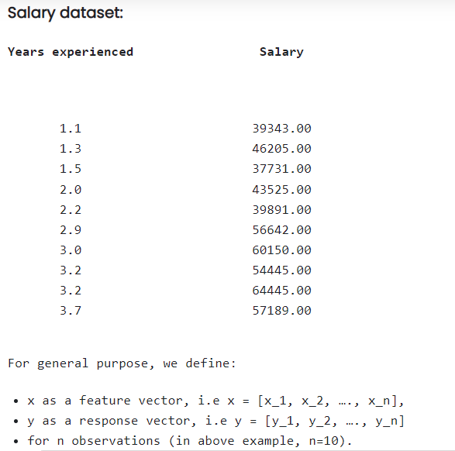

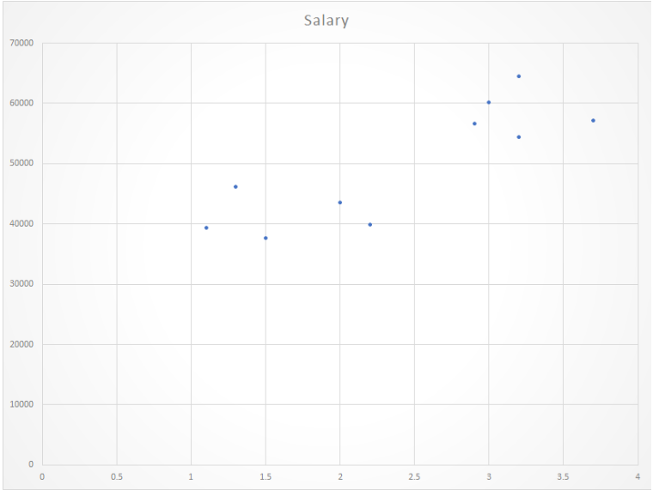

**Code And Output –**

library(RWeka)

setwd("C:\\Users\\RAHUL KUMAR\\Desktop\\r")

getwd()

library(tidyverse)

data()

head(cars,10)

cars %>%

lm(dist ~ speed, data =.)%>%

summary()

mod<- lm(dist ~ speed,data=cars)

mod

summary(mod)

attributes(mod)

mod$residuals

hist(mod$residuals)

new_speeds <- data.frame(speed=c(10,15,20))

predict(mod,new_speeds)%>%round(1)

cars %>%

lm(dist ~ speed, data=.) %>%

predict(data.frame(speed=c(10,15,20))) %>%

round()

